Members:

Mohammad Shash - 20200705

Sammy Medawar - 20210031

Ali Ghader - 20200379

Course: COSC333-ADAVNCED WEB PROGRAMMING

“Pizza Palace”

Presented to: Dr. Roaa Al Soloh

Fall 2023-2024

***Table of Contents:***

**Introduction3**

**IDEA 3**

**Project Scope4**

**Appendix 11**

**References12**

**Introduction:**

* Pizza palace website is a full functional website that involves combining functionality, visual appeal, and user-friendly features to enhance the overall customer experience.
* The website contains all the required services for a restaurant to succeed.

**IDEA:**

* A Good choice to involve variety of modern web features.
* Real-world application: A pizza restaurant website project can provide hands-on experience in facing a complex and real challenges during the development process, which provide valuable skills for web developers.

**Project Scope:**

* Login/Sign up
* Home
* About us/Contact us
* Menu / Menu item page
* Online ordering /Cart / Payment processing
* Admin Crud System
* Reviews
* Order History

The HomePage;

It is a responsive web page that consists of navbar to navigate through the website, an animated pizza, footer, Best Sellers and animated slider for the ingredients.

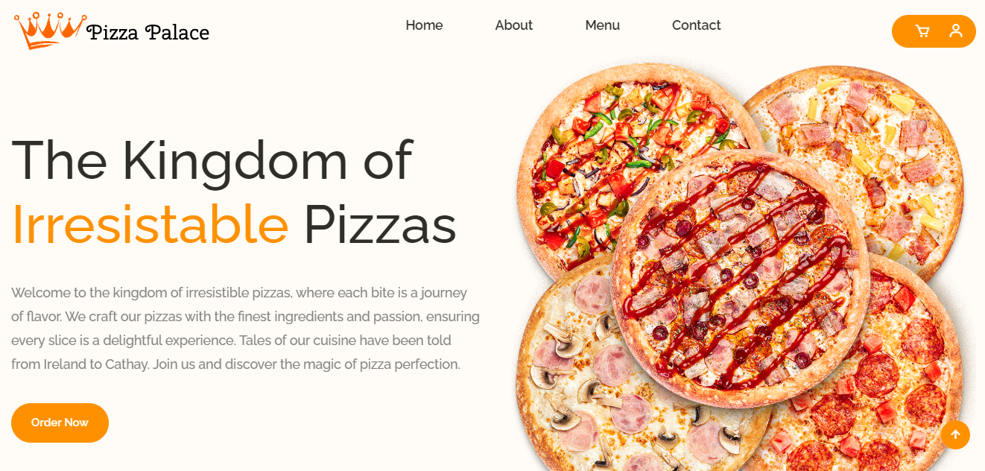

When the page is smaller simulating a smaller screen resolutions the navbar collapse and open upon click the slider, footer and items are resized.

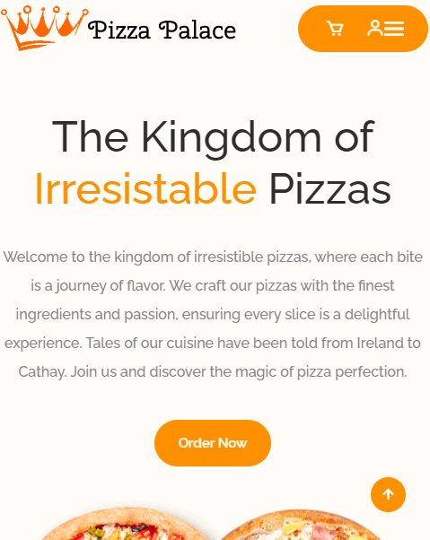

The About Us:

The About Us page contains information about the resturant Such as history, animated pizzas, meet our team section, and some contact details.

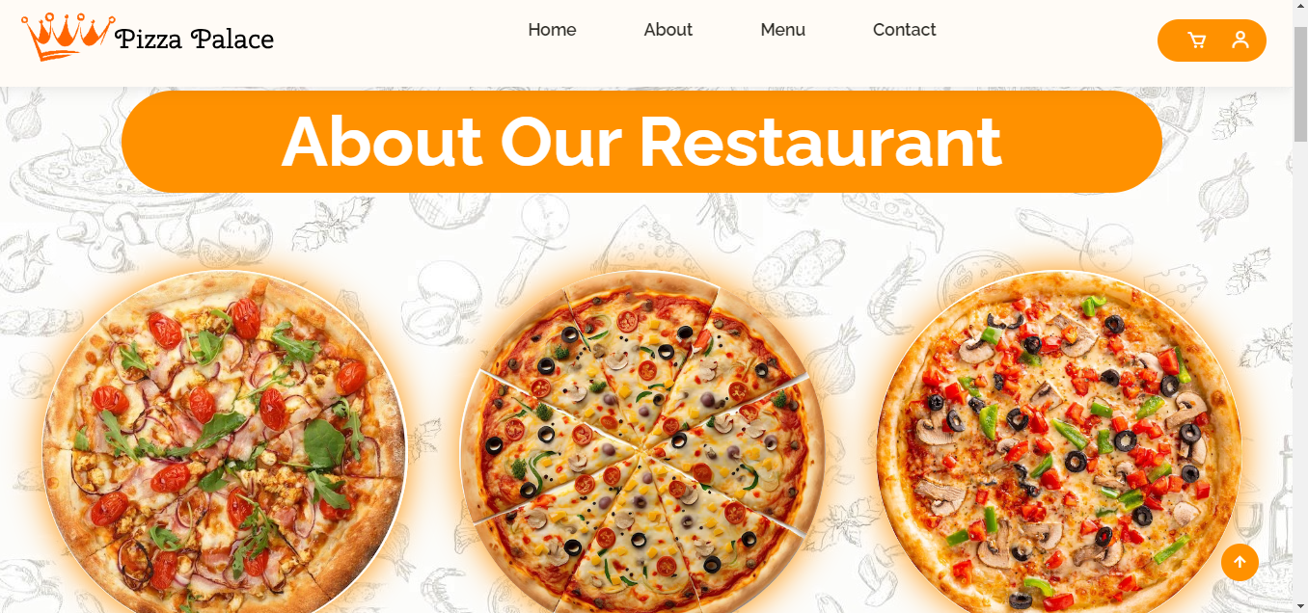

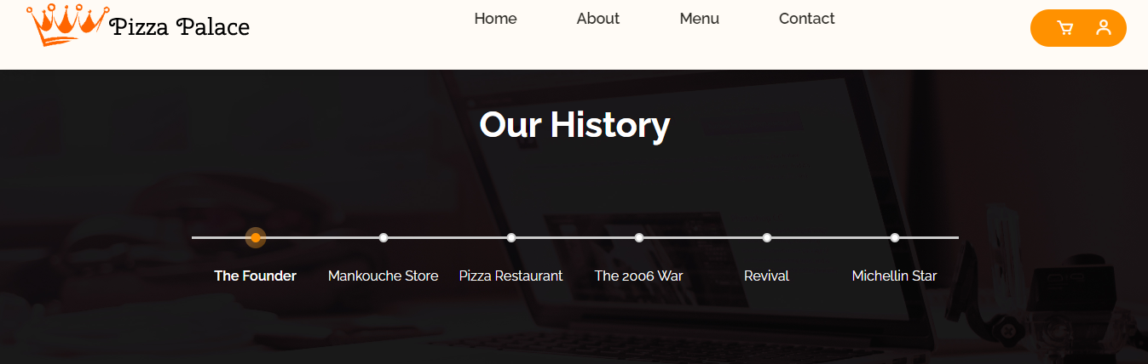

The Contact Us page:

Consists of a form to for the user to send a message, company contact information.

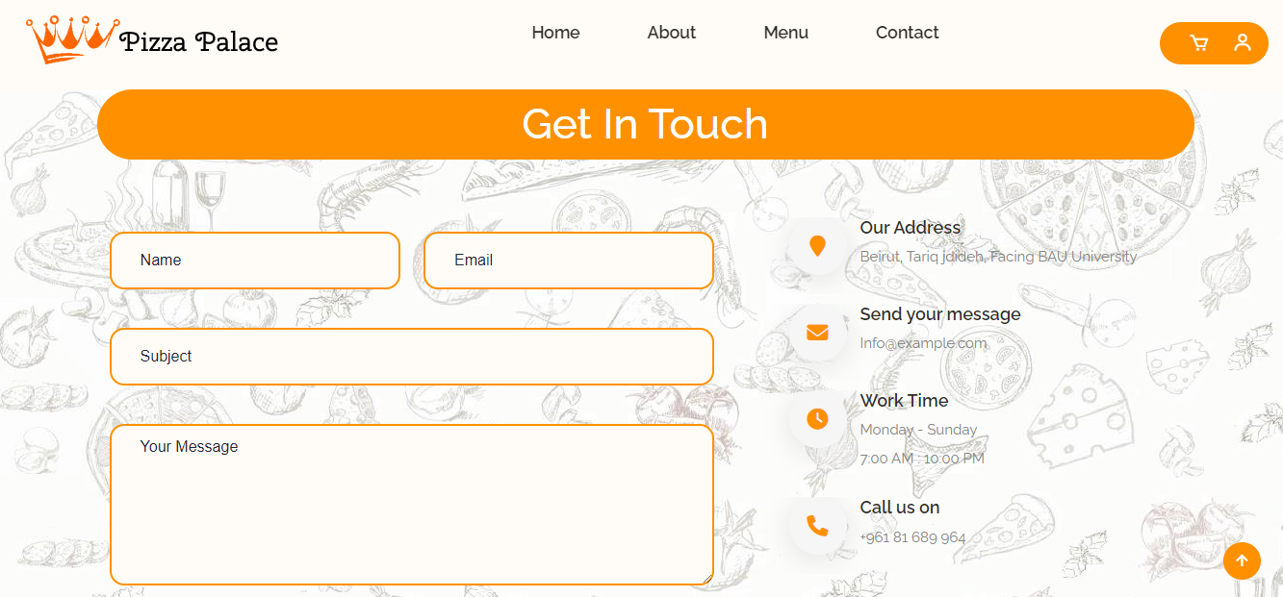

The Login Page:

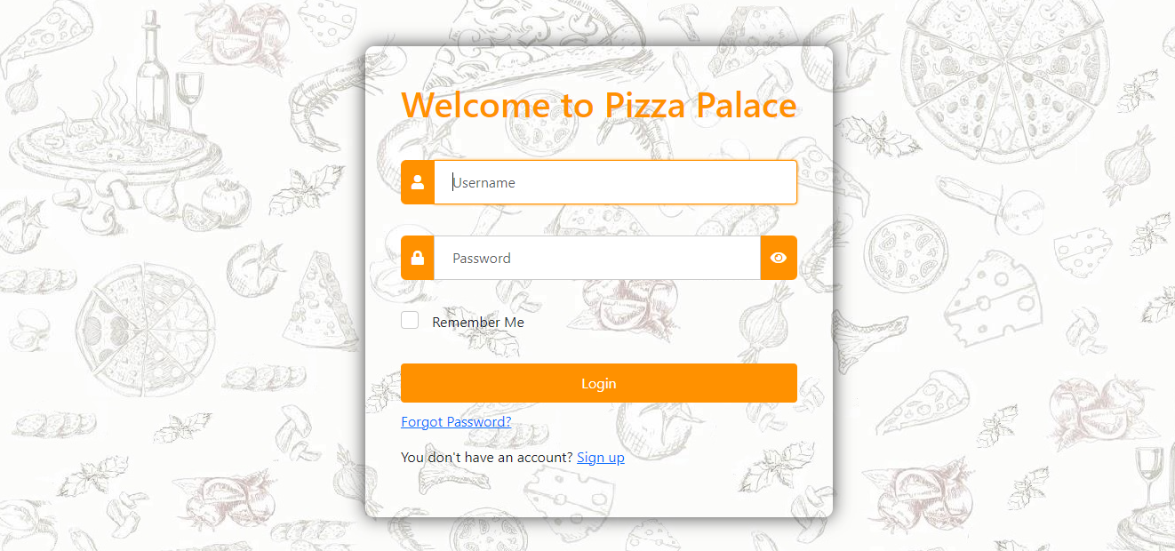

The login page allows the user to login and be able to do functionalities such as purchasing and rating pizzas it has a remember me option and forget password.

Sign Up: If new user the user should sign up with email, username, birthdate…

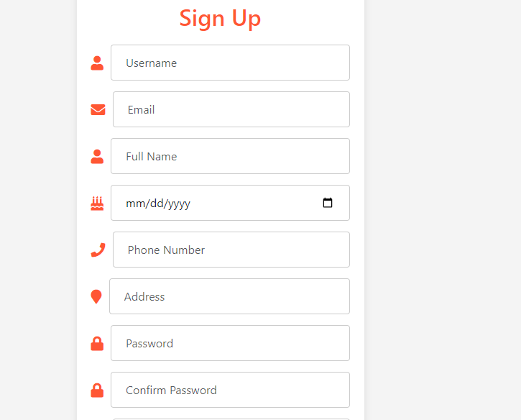

Profile:

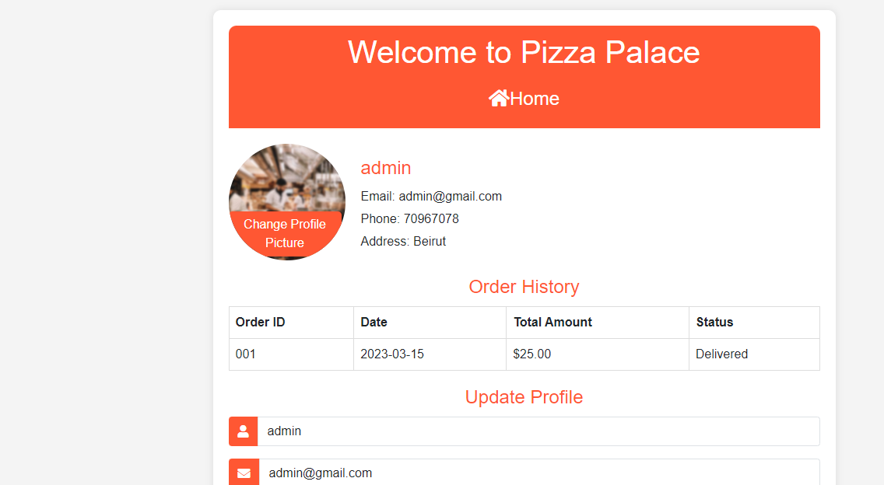

Logged in user can view his details update profile info, check orders see review and edit them along with changing password.

Menu Page:

Retrieves the available pizza from the Database user has the ability to check the reviews and check different pizza variants before ordering.

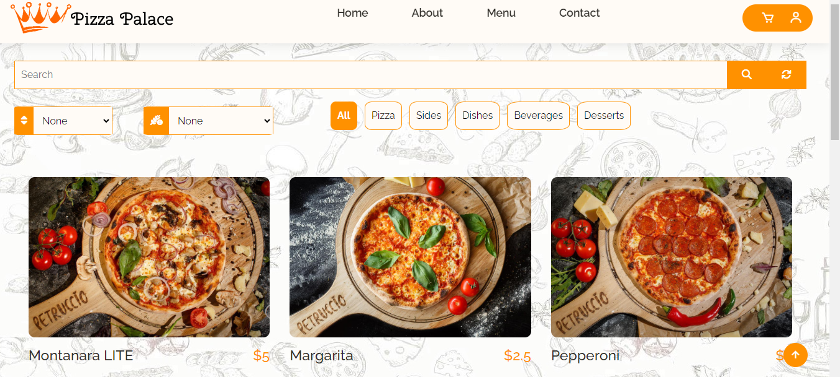

This page also allows user to filter pizzas according to category price and used ingredients.

Menuitem Page:

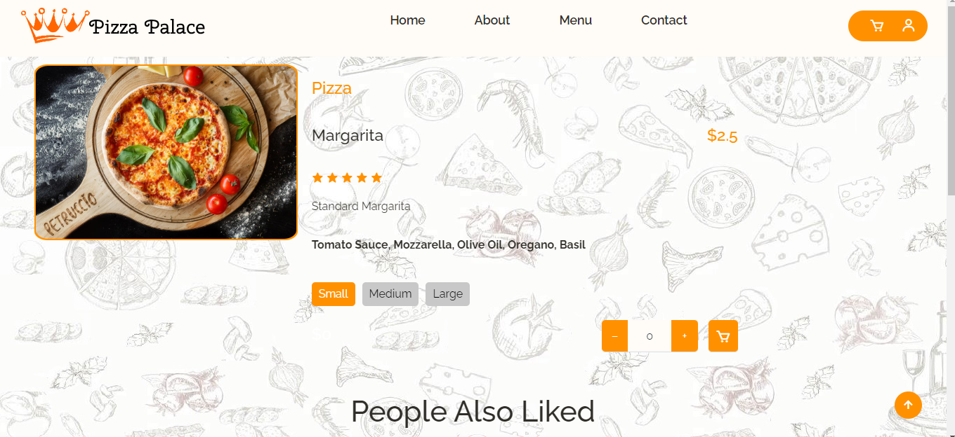

Is obtained when user clicks on pizza more details will be shown.

Admin Page:

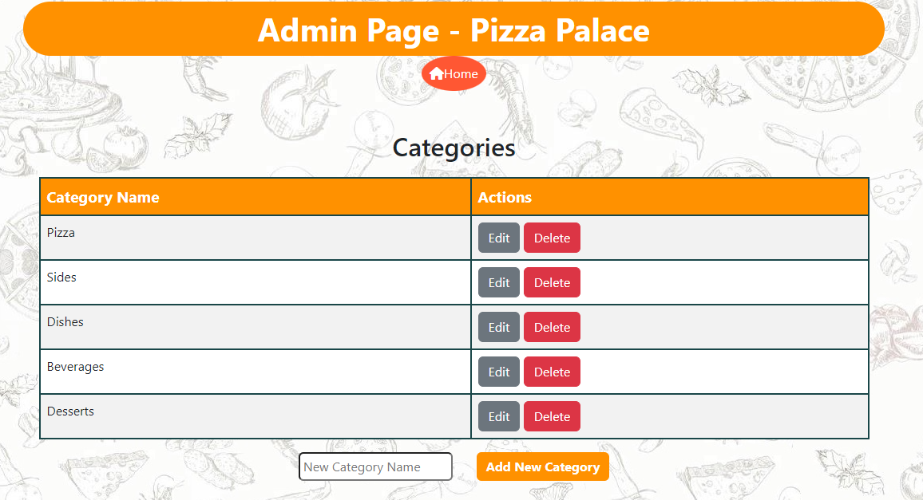

This page simulates the admin management system admin can edit, delete and add new category, ingredients and menuitems.

**Appendix:**

Bootstrap 5: Bootstrap is a free, open source front-end development framework for the creation of websites and web apps. Designed to enable responsive development of mobile-first websites, Bootstrap provides a collection of syntax for template designs.

 Visual Studio Code, also commonly referred to as VS Code, is a source-code editor made by Microsoft with the Electron Framework, for Windows, Linux and macOS. Features include support for debugging, syntax highlighting, intelligent code completion, snippets, code refactoring, and embedded Git.

In addition to Xampp, PHP MyAdmin, JQuery, and Awesome Fonts

**References:**

<https://getbootstrap.com/>

<https://www.w3schools.com/>